Fueling Change: A Family Business Transforms Fuel Supplies and Its Community
http://bit.ly/FacesBehindTheFacts2018

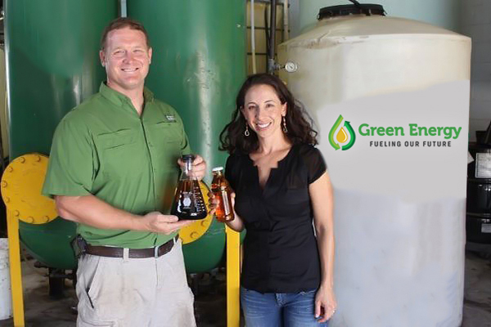
Green Energy Biofuel
BioJoe and Beth Renwick, Founder and President
Columbia, South Carolina
12 Employees
https://gebiofuel.com/

In 2007, as gas prices were passing $5 a gallon, Joe and Beth Renwick were looking to cut costs in their family budget. They decided to experiment with making their own fuel in their garage working with used cooking oil to create biodiesel. What they found was that everyone else's trash was their treasure. Joe and Beth realized that waste vegetable oils, often discarded by schools and restaurants, could be cleaned and recycled into biodiesel fuel, which could then be used to run anything with a diesel engine. Soon, the Renwicks found themselves launching a biofuel business that would extend the economic benefits of biofuel from their family, to the local community, and on to the greater Southeast region.

Founded in 2008 as Midlands Biofuels, the company quickly spread its reach beyond South Carolina into multiple states in the southeast region. In 2016, the Renwicks renamed their firm Green Energy Biofuel to reflect both its commitment to providing clean energy and the geographic expansion of the company. The firm has secured major corporate customers with a high volume of product, and as a result, have invested in significant plant modifications to increase the efficiency of processing the used cooking oil received from customers to 3.6 million gallons per year. Most recently, they have purchased and are redesigning a former biofuel plant capable of producing over 40 million gallons per year in Aiken, SC. This level of biofuel production will decrease emissions by 752,254,400 pounds each year.
The "fearless leader" of Green Energy Biofuel is Joe Renwick, who goes by the moniker “BioJoe” and attributes his leadership skills to lessons learned at The Citadel, one of the toughest military academies in the U.S. The academy's core values, “Duty, Pride & Honor” were instilled in Joe and can now be found in every aspect of this company. Simple yet strong values have set their company apart from competitors. “It is a long term play, to do things the right way”, says BioJoe, “but after 10 years in business we are growing faster now than we could have ever if we took shortcuts.”

BioJoe is well matched by “BioBeth” his wife, business partner, and ER Doctor. Dr. Beth Renwick is a decisive leader who can make logical and calculated choices on the fly. Beth is the majority owner making Green Energy Biofuel the nation’s only woman owned full service biofuel company that collects, processes, and sells their own biofuel directly to customers in the U.S.

“The fuel produced is not only biodegradable, but non-hazardous," says BioJoe. "Our mission is to increase the availability of alternative fuels in South Carolina and create sustainable green jobs in the biofuels industry.”
Green Energy Biofuel provides two key services to food industry establishments: (1) cooking oil collection and (2) grease trap pumping. The company maintains a fleet of specialized trucks that criss-cross the Southeast to collect waste cooking oil. However, not every establishment has the best infrastructure to facilitate grease collection, so Green Energy Biofuel also installs custom vacuum operated grease traps in these kitchens. One advantage for restaurants is that the specialty grease traps pay for themselves as restaurant owners sell waste oil to Green Energy Biofuel and are paid by the gallon.
On the receiving end of the finished biofuel, the company works to make its product as accessible as possible to any vehicle. Green Energy Biofuel sells its purified feedstock to large biodiesel manufacturers which produce biofuel on a much larger scale. BioJoe and Beth’s trucks run on South Carolina biodiesel, but most newer engines would require some modification to accept 100% biofuel. Instead, many engines can accept a mixture of 20% biodiesel and 80% regular diesel as a drop-in fuel. This mixture burns more efficiently than regular petroleum diesel, lubricates the engine, cleans out engine particulates, and emits less pollutants than petroleum diesel. The benefits of using biodiesel are so great that it is now blended into every gallon of biofuel sold in America at almost 5% or less. Not to be overlooked, the exhaust also smells like french fries which is a nice improvement from the odor of petroleum diesel.
BioJoe and Beth’s Favorite Fact
(2018 Sustainable Energy in America Factbook)
Biodiesel biodegrades faster than sugar
and is less toxic than table salt.
Biodiesel blends can run in anything that uses diesel fuel with NO modifications required!

As a result of the company's success, BioJoe and Beth are able to pay that success forward by giving schools, colleges, and small businesses back a percentage of profits from collections. They named their unique program “BIO4EDU”. Green Energy Biofuel also provides opportunities for children to tour the production facility and learn how biofuels are made. In addition, they offer college internships allowing students to gain 3 credit hours as well as paid positions during the summer and often offer post graduate jobs. It is impressive to note that last year alone over $250,000 was paid out to their over 1,000 customers in exchange for waste cooking oil.

“As long as we are ‘Making Fuel Baby,’ we will always be a proud supporter of furthering education,” says BioJoe.
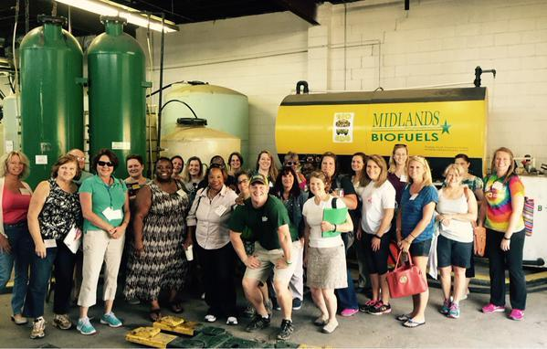
Green Energy Biofuel, which showcases business materials alongside quirky photos of the staff and family events on its website, isn’t just producing biofuel. In addition to fueling trucks in the Southeast from its collection stream, Green Energy Biofuel is producing sustainable jobs, bolstering the bottom lines of businesses, and enhancing local communities. Remarkably, all of this starts in the kitchen.
—Alex Gerard, Business Council for Sustainable Energy and Jordon DeGroote, Clean Energy Business Network

